**A LINE FOLLOWING ROBOT**

**“ABHIMANYU”**

**“अभिमन्यू”**

***TEAM A2:***

***Nischal Parajuli (mentor)***

***Pramesh aryal***

***Anup bagale***

***Soniya Adhikari***

***Sanjaya poudel***

***Swachhanda aryal***

A line follower is an automated machine designed to navigate a predefined path, typically represented by a visible black line on a contrasting white surface. Its operational principle revolves around detecting the line using sensors and continuously correcting its movements based on the feedback received. This simple yet effective system has a wide range of applications, including but not limited to automobile industry, industrial automation, and guidance systems in various fields. By leveraging the line-following technology, these machines can accurately follow paths, ensuring precise maneuvering and efficient control in diverse scenarios.11

**BACKGROUND**

In today's increasingly technology-driven world, the significance of not just utilizing technology but also comprehending its creation cannot be overstated. As an engineer, it is crucial to possess a solid understanding of diverse disciplines. Many projects tend to be confined to a specific field, which can limit innovation and creativity. However, undertaking a project that spans multiple disciplines, such as mechanical, electronics, electrical, and programming skills, can broaden one's horizons and foster a holistic approach.

Such multidisciplinary projects, like designing a robot, offer more than just the ability to track and follow a designated path. They incorporate the integration of ultrasonic sensors, enabling the robot to detect obstacles. By embarking on these projects, several benefits arise:

1. Visual Grasp of Math and Science: The practical application of math and science concepts in building a robot provides a tangible understanding of these subjects.
2. Development of Logical Thinking: Multidisciplinary projects encourage the cultivation of logical thinking skills, as engineers must tackle challenges by considering different perspectives and making connections between various disciplines.
3. Stimulation of Innovation and Creativity: Working across disciplines fosters a creative mindset, as engineers are prompted to explore unconventional solutions and think outside the box.
4. Enhancement of Problem-Solving Skills: The integration of diverse disciplines necessitates the development of effective problem-solving techniques, enabling engineers to address complex issues from multiple angles.

In summary, the design of a robot that not only tracks and follows a path but also incorporates obstacle detection through ultrasonic sensors provides a practical platform for learning, enhances skills in mathematics and science, nurtures logical thinking, stimulates innovation and creativity, and improves problem-solving abilities.

**MOTIVATION**

The ability of ants to travel in a line and the use of lanes on roads to avoid accidents and traffic jams inspire the concept of a line-following robot. This project aims to recreate nature's efficiency in machines to solve problems and meet requirements. Potential areas that could benefit from this project include industrial automated equipment carriers, entertainment and small household applications, tour guides in museums, and second wave reconnaissance operations. By developing a line-following robot, we can harness the power of nature-inspired robotics to enhance various industries and fulfill diverse needs.

**Q. What is Line Follower Robot?**

A Line Follower Robot (LFR) is a machine designed to navigate a path, which can be visually represented by a black line on a white surface or vice versa. Additionally, the path can be intangible, relying on cues like a magnetic field. The LFR's purpose is to detect and follow this path using its sensing capabilities.

**Arduino nano:** The brain of the line follower robot is powered by an Arduino, which serves as an open-source electronic platform. In this particular project, an Arduino Nano board is utilized. The decisions made by the robot are based on the feedback received from its sensors, with the Arduino processing and interpreting this information.

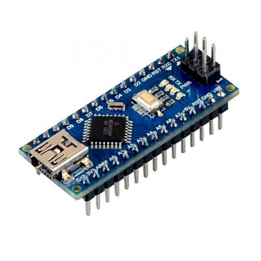

**Motor Driver:** To enable motor control, a motor driver is employed, as it meets the necessary current requirements that direct connection to the motors cannot fulfill. The motor driver connects the motors to the Arduino for coordinated movement.

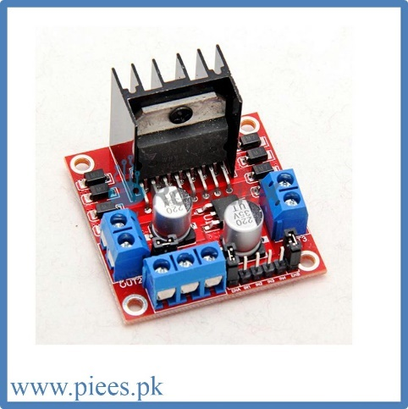

**Motor**: Geared DC motors are employed as the main actuators for the robot, providing the necessary propulsion.

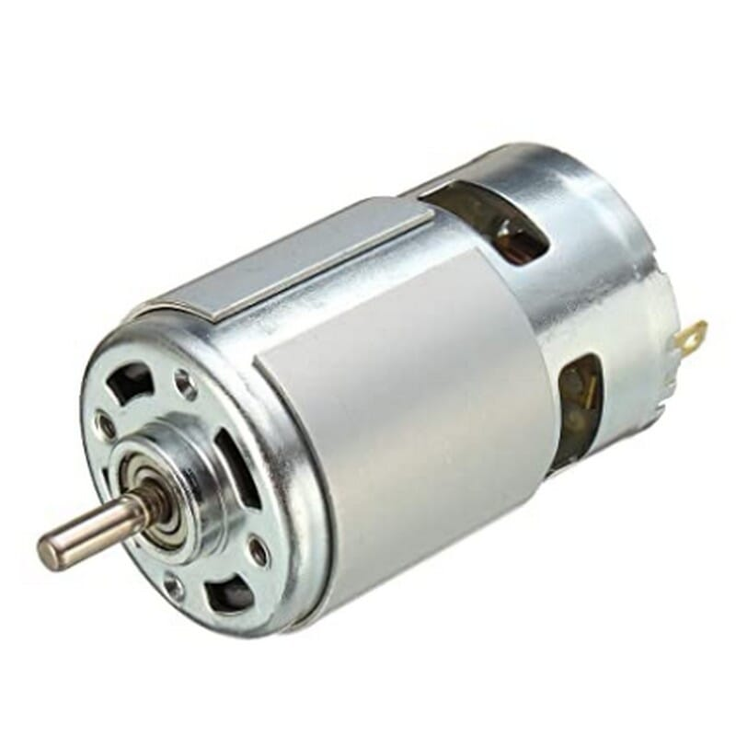

**Sense Array**: For feedback on the robot's position relative to the line, a sensor array is employed. This array consists of light-dependent resistors (LDRs) serving as sensors, with LEDs used as the light source.

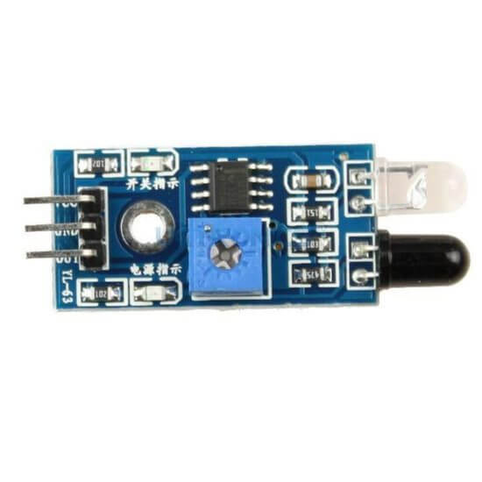

[This Photo](https://uelectronics.com/producto/fc-51-sensor-de-obstaculos-reflectivo-infrarojo/) by Unknown Author is licensed under [CC BY-NC-ND](https://creativecommons.org/licenses/by-nc-nd/3.0/)

**Ultrasonic sensor:** To detect obstacles while the robot follows the line, an ultrasonic sensor is utilized.

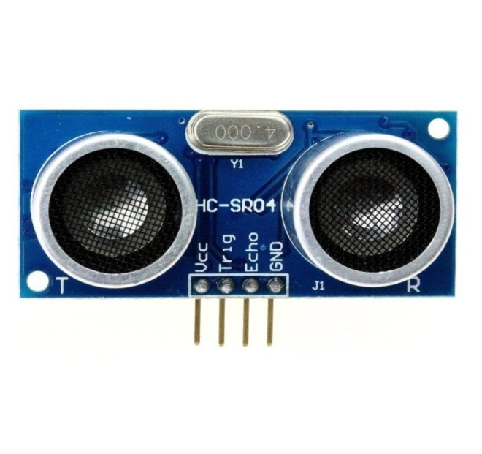

**Power supply:** Power for the robot is supplied by a 12V battery, regulated to 5V using a motor driver module.

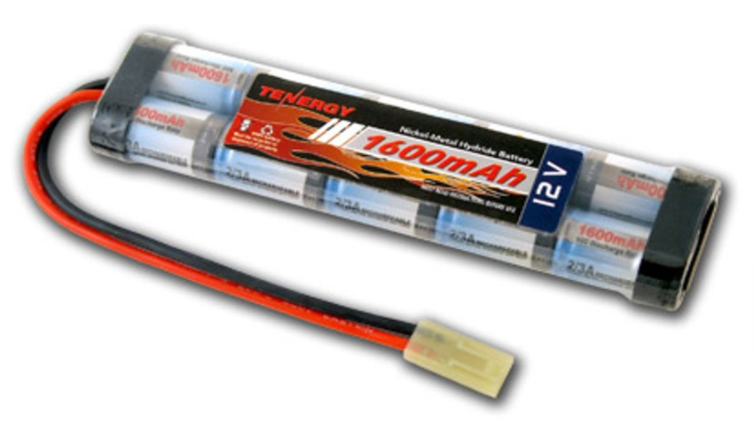

**Wheels and castor wheels:** The robot features wheels and caster wheels, each with a diameter of 5cm, facilitating smooth movement.

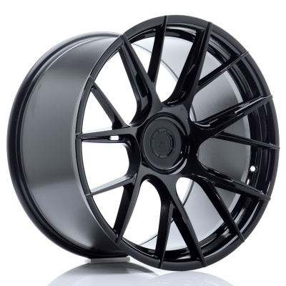

**Plywood chassis:** The chassis of the robot is constructed using plywood, providing a sturdy base for mounting the components.

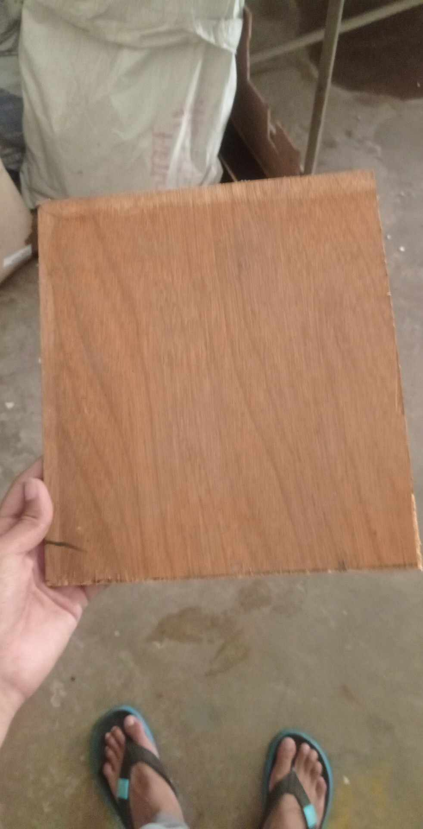

**Jumper wires:** Jumper wires are used to establish connections between various components, ensuring proper electrical connectivity throughout the robot.

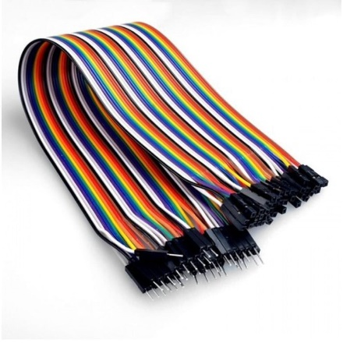

OBJECTIVES

The project aims to achieve the following objectives:

1. Line Following Capability: The robot should possess the ability to accurately track and follow a designated line.

2. Variable Turning Capability: The robot must be capable of executing turns at different angles, allowing flexibility in its path-following behavior.

3. Insensitivity to Environmental Factors: The robot should be designed to minimize the impact of environmental factors such as variations in lighting conditions and background noise, ensuring consistent performance.

4. Calibration of Line Darkness Threshold: The system should provide a means to calibrate the threshold for detecting the darkness or lightness of the line, allowing adjustments based on different line characteristics.

5. Scalability Considerations: The design of the robot should prioritize scalability, allowing for potential future enhancements and modifications to accommodate changing requirements or additional functionalities.

APPLICATIONS

The project has potential applications in the following areas:

1. Industrial Automated Equipment Carrier: The line-following robot can be utilized to automate the transportation of equipment within industrial settings.

2. Automated Cars: The technology developed in this project can be applied to autonomous vehicles, enabling them to navigate roads and follow lane markings.

3. Tour Guide in Museums and Similar Applications: The line-following robot can serve as an interactive guide in museums or other similar settings, providing visitors with informative commentary and leading them along designated paths.

4. Intra-office Mail/Message Delivery: The robot can be employed to efficiently deliver mail or messages within office buildings, streamlining internal communication processes.

5. Medication Delivery in Hospitals: Within hospital environments, the line-following robot can be utilized to safely and accurately deliver medications to different wards or departments, enhancing operational efficiency.

By adapting the line-following technology to these specific applications, the project has the potential to revolutionize industrial automation, transportation, guided tours, intra-office logistics, and healthcare services.

ADVANTAGES

The utilization of line-following robotic vehicles in industries enables efficient transportation of materials from one location to another.

These robots typically operate in an automatic mode, requiring minimal manual intervention once installed.

The system within the robot is designed for reliability and can be considered a "install and forget" solution.

Line-following robots offer a cost-effective option for material transportation in industries.

The simplicity of building such robots makes them accessible and practical for various applications.

Additionally, line-following robots can be used for long-distance operations, extending their capabilities beyond short-range tasks.

DISADVANTAGES

The movement of a line-following robot (LFR) is constrained to a fixed track or path.

A reliable power supply is necessary to ensure the continuous operation of the robot.

The lack of speed control in LFRs can sometimes result in instability during operation.

The selection of the line to follow is determined by hardware abstraction and cannot be altered or adjusted through software control.

CONLCLUSION

The Line Following and Obstacle Detecting robot relies on properly formatted and coded sensors, including IR sensors for line following and US sensors for obstacle detection. While the components work well, there may be challenges with turning due to the high speed of the robot. With a limited number of available PWM pins, it might be difficult to handle all the required pins for optimal performance.

~THANK YOU~